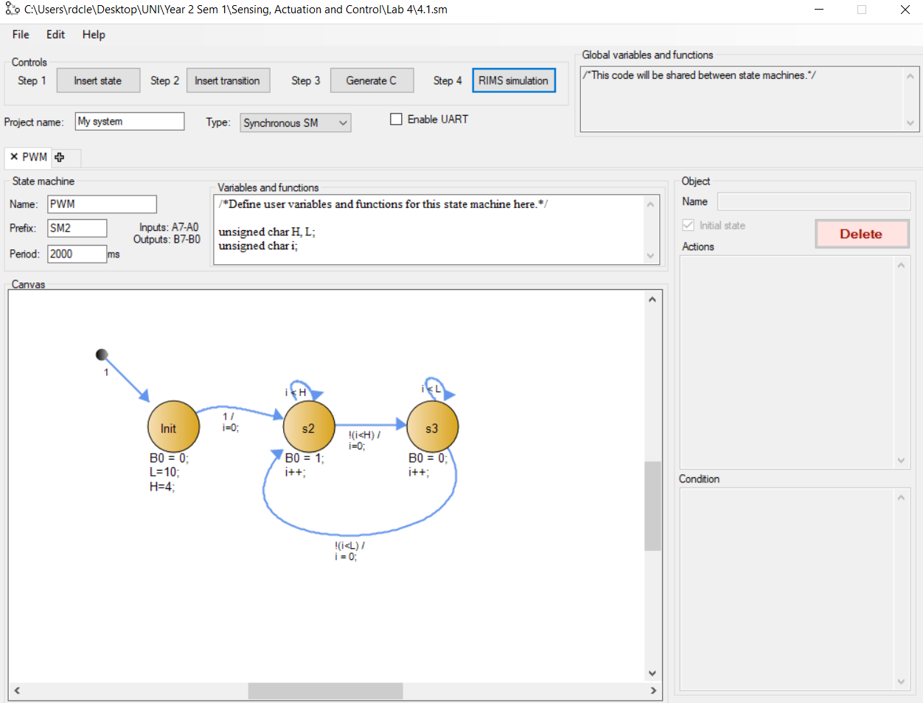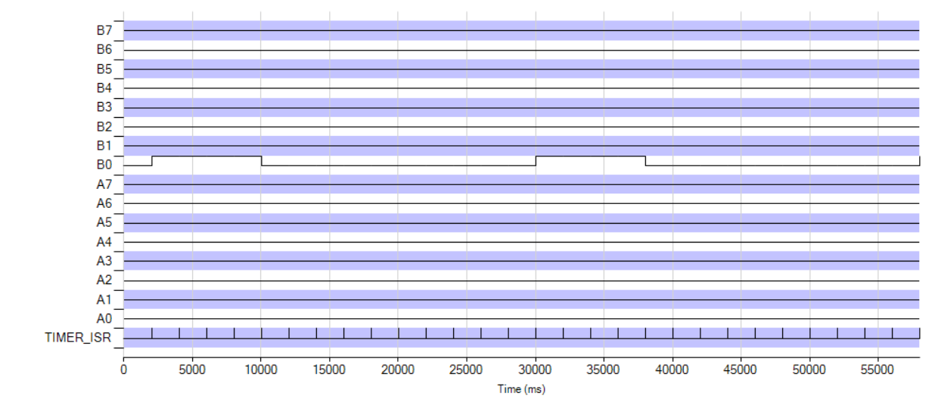

2.1

#include "rims.h"

unsigned char RxISRFlag;

void RxISR(){

RxISRFlag = 1;

void main()

{

unsigned char ascii;

UARTOn();

RxISRFlag = 0;

while (1) {

while(!RxISRFlag){}

RxISRFlag = 0;

ascii = R;

}

}

2.2

#include "rims.h"

unsigned char RxISRFlag;

void RxISR(){

RxISRFlag = 1;

}

void main()

{

unsigned char ascii;

UARTOn();

RxISRFlag = 0;

while (1) {

while(!RxISRFlag){}

RxISRFlag = 0;

ascii = R;

if (A0){

if (ascii>=97&&ascii<=122){

ascii = ascii-32;

}

else if (ascii >=65&&ascii<=90){

ascii = ascii + 32;

}

}

}

}

2.3

#include "rims.h"

unsigned char RxISRFlag;

void RxISR(){

RxISRFlag = 1;

}

void main()

{

unsigned char ascii;

UARTOn();

RxISRFlag = 0;

while (1) {

while(!RxISRFlag){}

RxISRFlag = 0;

ascii = R;

if (A0){

if (ascii>=97&&ascii<=122){

ascii = ascii-32;

}

else if (ascii >=65&&ascii<=90){

ascii = ascii + 32;

}

}

}

}